Bash Scripts
To check the condition for “if else” statements
Commands I used:
vi script.b:ash
chmod 755 script.bash
cat script.bash
./script.bash
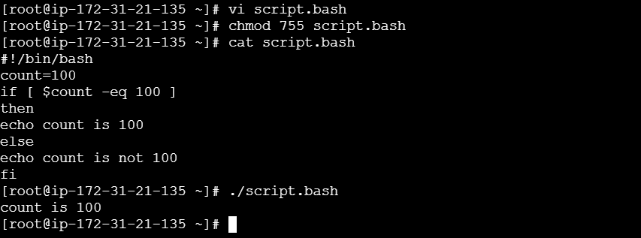

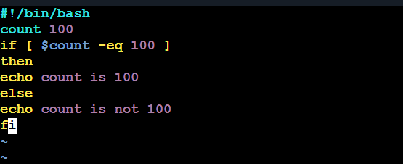

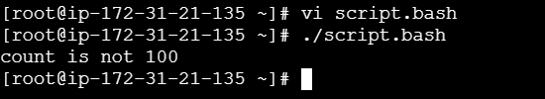

To check any file/directory is available in particular location.

Commands I used:
vi file.bash
chmod 755 file.bash
cat file.bash
./file.bash
cd /teja/
cd scripts

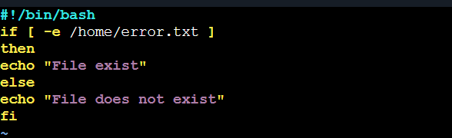

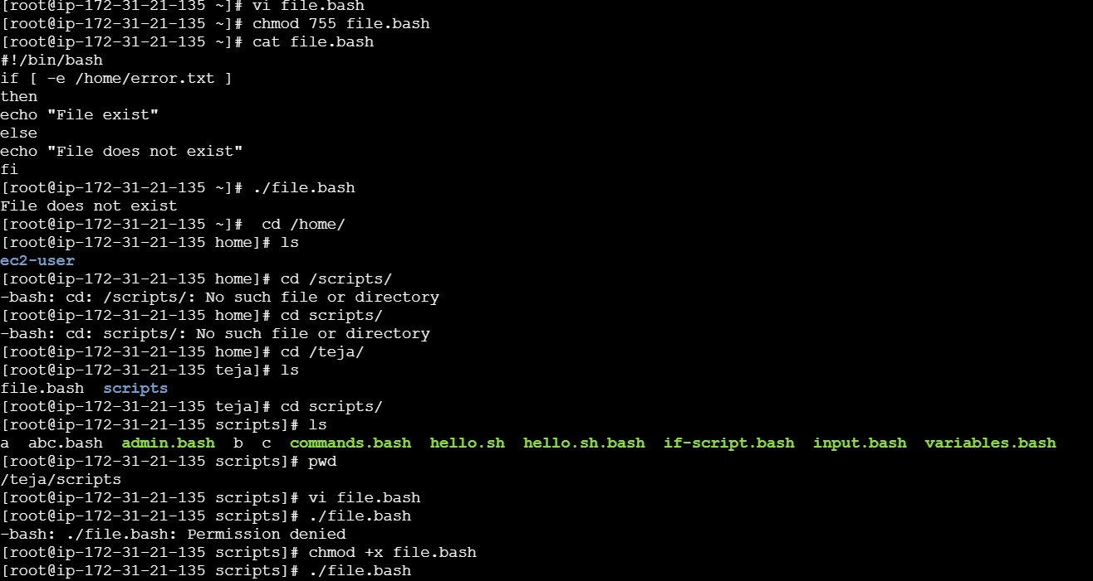

To check the case statement scripts
Commands I used:
vi case.bash
chmod 755 case.bash
cat case.bash
./case.bash
And enter the choices(ex:a,b,c,d)
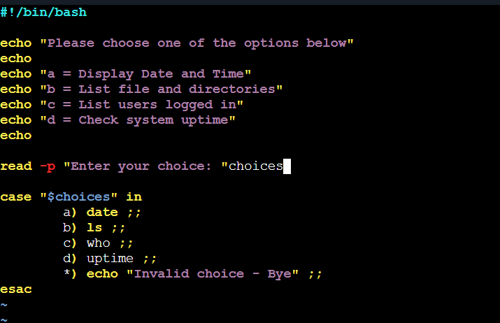

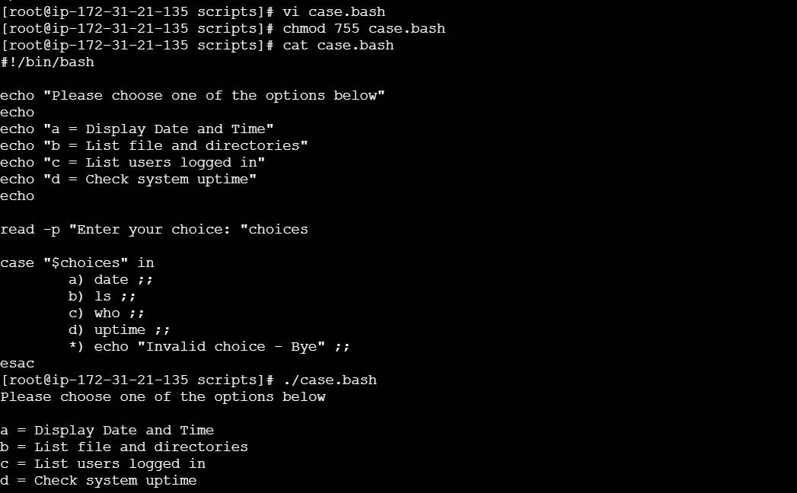

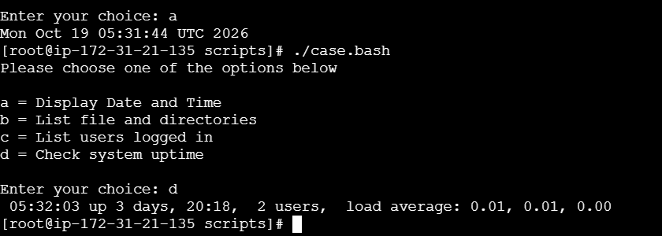

To check the “for loop” scripts
Commands I used:
vi forloop.bash
chmod forloop.bash
cat forloop.bash
./forloop.bash

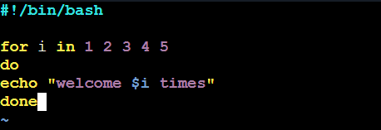

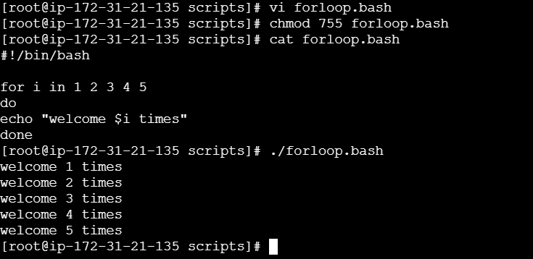

For 100 times

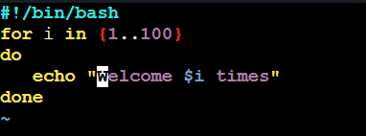

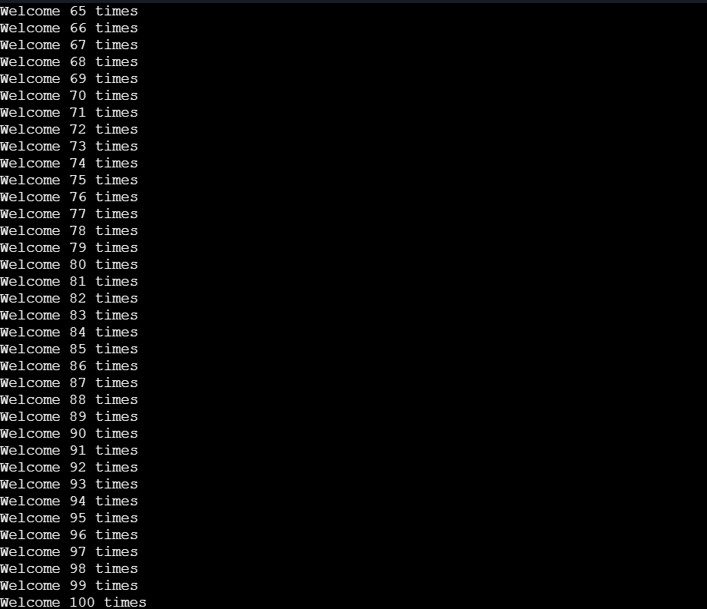

To check for “Do-while loop” scripts
Commands I used:
vi whileloop.bash
chmod 755 whileloop.bash
cat whileloop.bash
./whileloop.bash
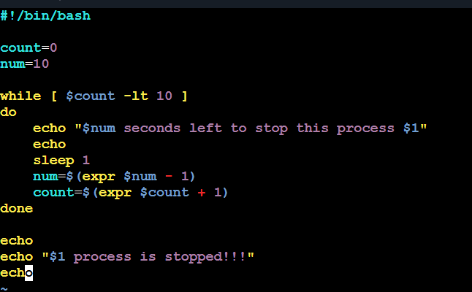

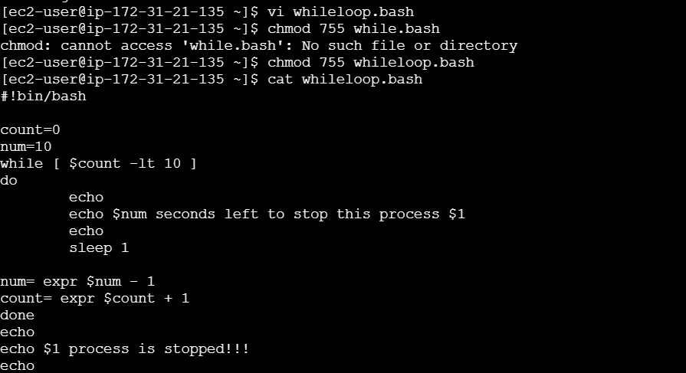

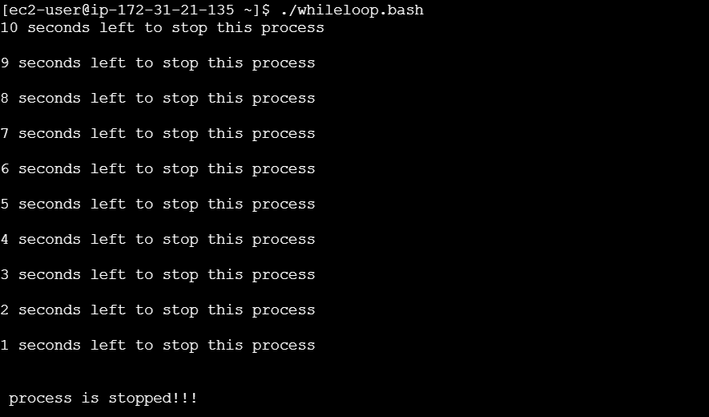

To check the exit status(to know the status of the previous command)
Commands I used:
vi exitstatus.bash
chmod 755 exitstatus.bash
cat exitstatus.bash
./existstatus.bash

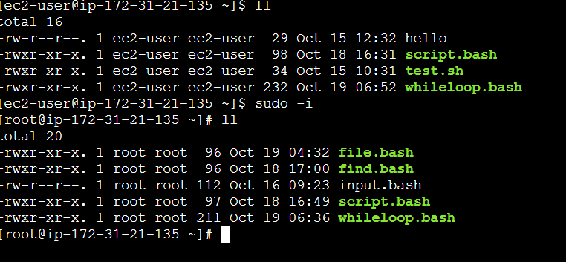

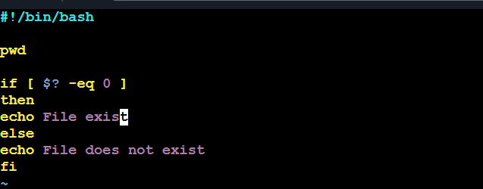

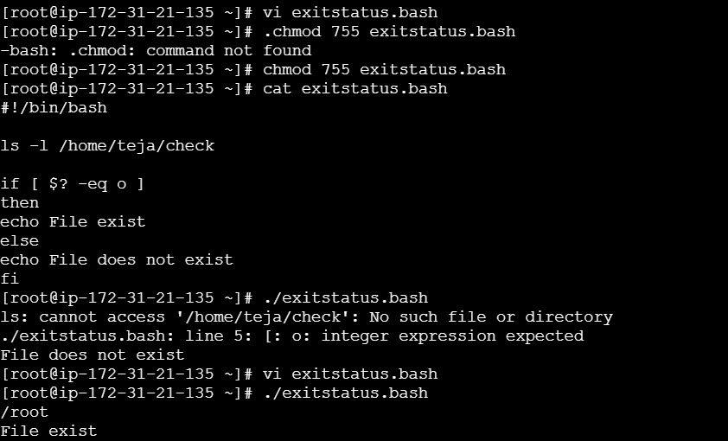

To configure a cronjob
Commands I used:
crontab -l
cat /tmp/cronlog.txt
ls -l /root/test/
pwd
ls -l
date
mkdir -p /root/cronjob

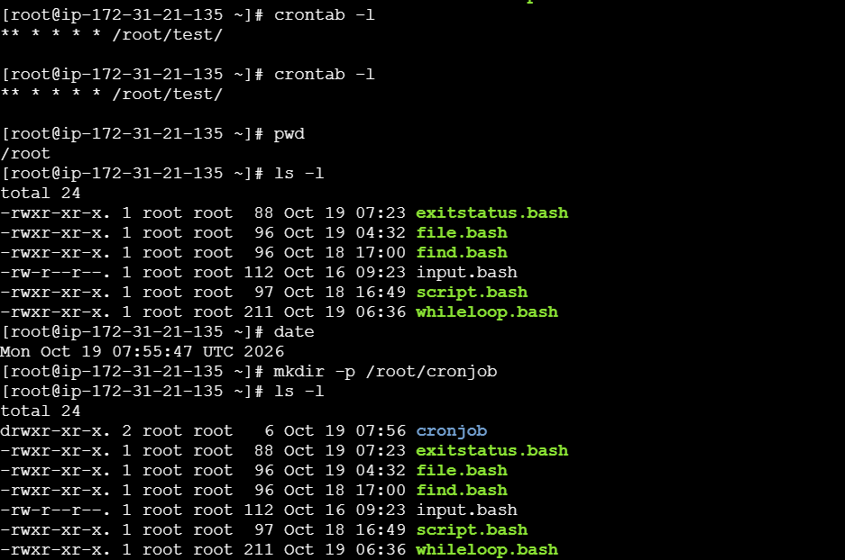

Bash Script Tasks

1.Create a bash script to check if a directory is available or not
- Open AWS EC2 Instance Connect.
- Switch to root using sudo -i.
- Navigate to the task directory using cd /root/bash_tasks.
- Create or open the script using vi task1.sh.
- Enter the Bash commands and save using Esc, :wq!, Enter.
- Execute using bash task1.sh
Commands I used:
sudo -i
pwd
whoami
mkdir -p /root/bash_tasks
vi task1.sh
bash task1.sh

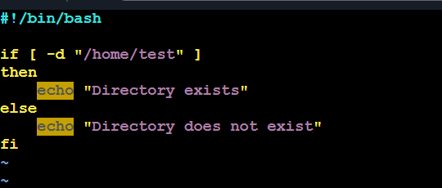

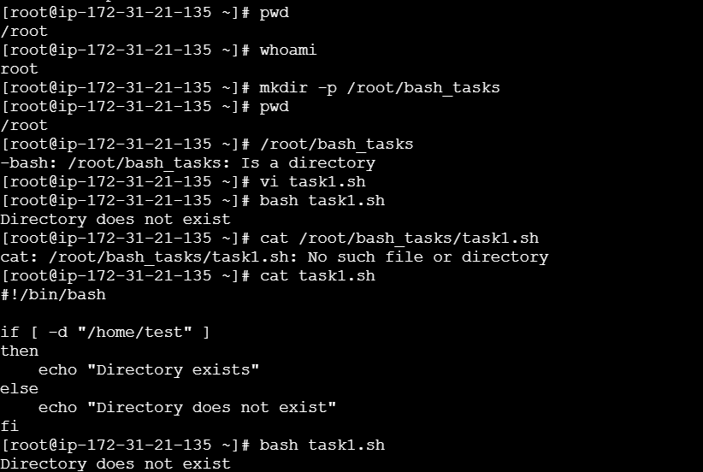

2.Create a bash script to create multiple files
- Open the EC2 terminal.
- Navigate to /root/bash_tasks.
- Open the script using vi task2.sh.
- Enter the file-creation commands and save the script.
- Execute using bash task2.sh.
- Verify the files using ls -l.
Commands I used:
Cd /root/bash_tasks
vi task2.sh
bash task2.sh
ls -l file*.txt
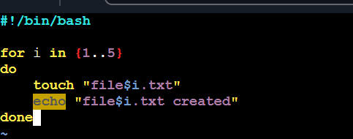

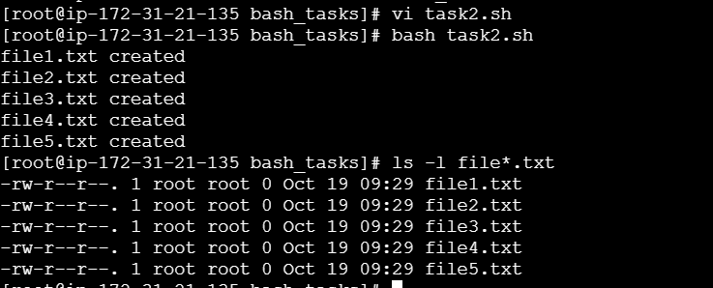

3.Create a bash script to take a backup of a directory.
- Open the EC2 terminal.
- Navigate to /root/bash_tasks.
- Create a test directory and a sample file.
- Open the script using vi task3.sh.
- Enter the backup commands and save the script.
- Execute using bash task3.sh.
- Verify the backup using ls -lh
Commands I used:
cd /root/bash_tasks
mkdir -p /root/test_backup
echo "This is my backup test file" > /root/test_backup/file1.txt
ls -l /root/test_backup
vi task3.sh
bash task3.sh
ls -lh /root/backups
tar -tzf /root/backups/backup_*.tar.gz
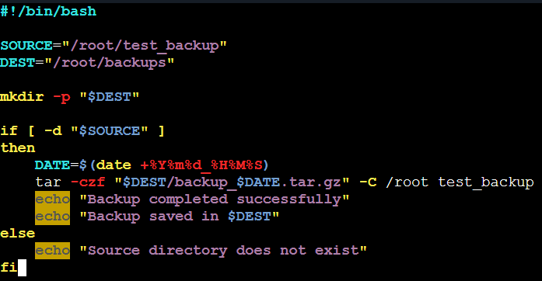

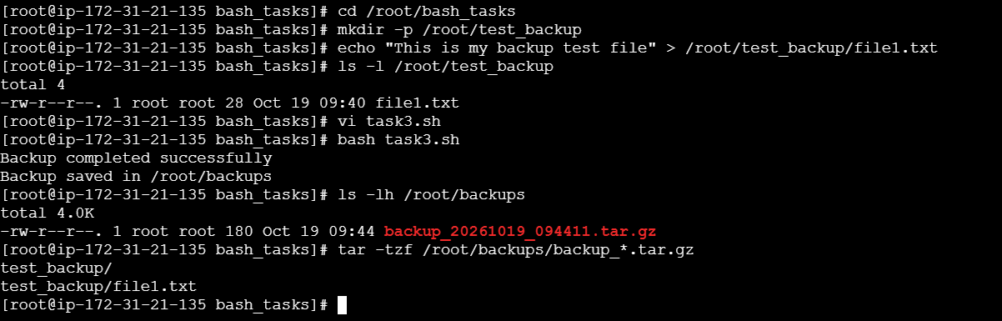
4.Create a bash script to install Nginx on an EC2 server
- Open the EC2 terminal.
- Log in as root.
- Install Nginx using dnf install nginx -y.
- Start and enable Nginx using systemctl enable --now nginx.
- Check the service using systemctl status nginx.
- Confirm that the service shows active (running).
Commands I used:
cat /etc/os-release
cd /root/bash_tasks
vi task4.sh
bash task4.sh
systemctl status nginx
systemctl is-active nginx
curl -I http://localhost
cat /root/bash_tasks/task4.sh
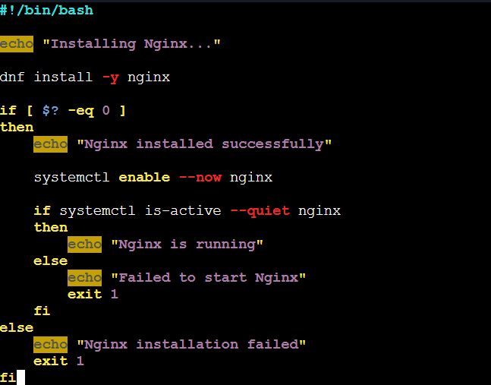

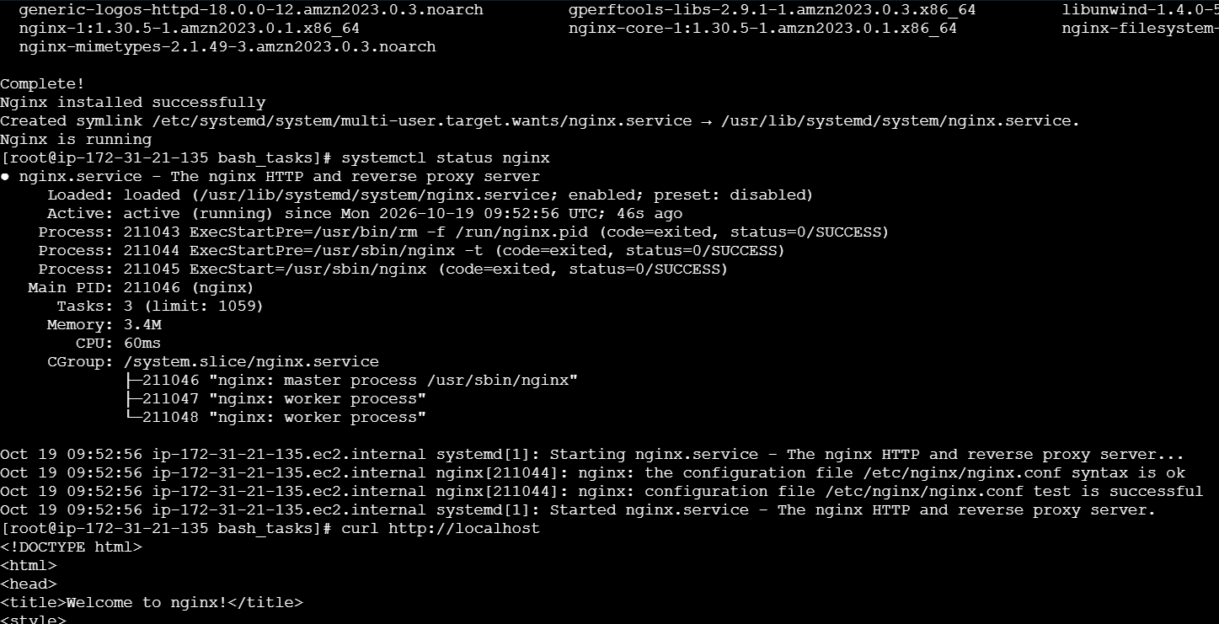

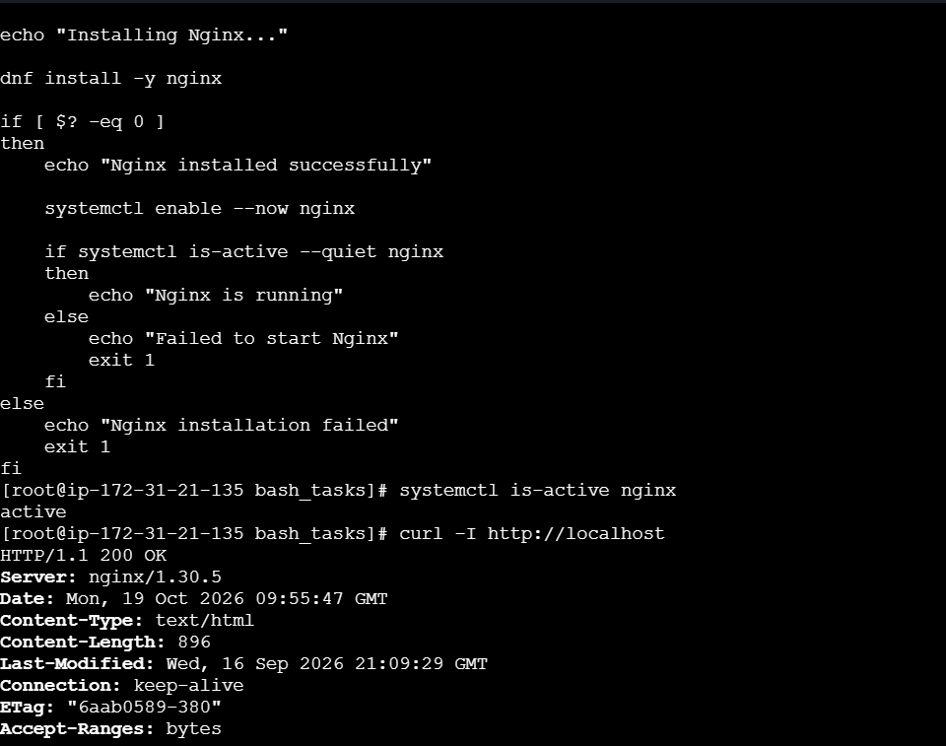

5. Create a bash script to install Apache Tomcat on an EC2 server.
- Open the EC2 terminal.
- Check Java using java -version.
- Download the Tomcat archive using curl.
- Extract the archive using tar -xzf.
- Move the extracted directory to /opt/tomcat.
- Configure and enable the Tomcat service.
- Verify using systemctl status tomcat and curl -I http://localhost:8080
Commands I used:
java -version
cd /tmp
curl -fLO https://archive.apache.org/dist/tomcat/tomcat-10/v10.1.52/bin/apache-tomcat-10.1.52.tar.gz
tar -xzf apache-tomcat-10.1.52.tar.gz
mv apache-tomcat-10.1.52 /opt/tomcat
ls /opt/tomcat
vi /etc/systemd/system/tomcat.service
systemctl daemon-reload
systemctl enable --now tomcat
systemctl status tomcat
curl -I http://localhost:8080
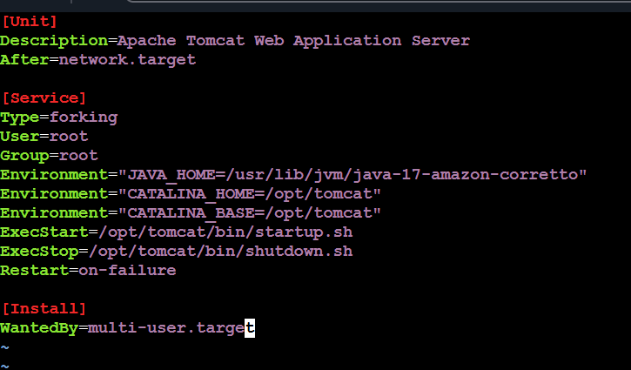

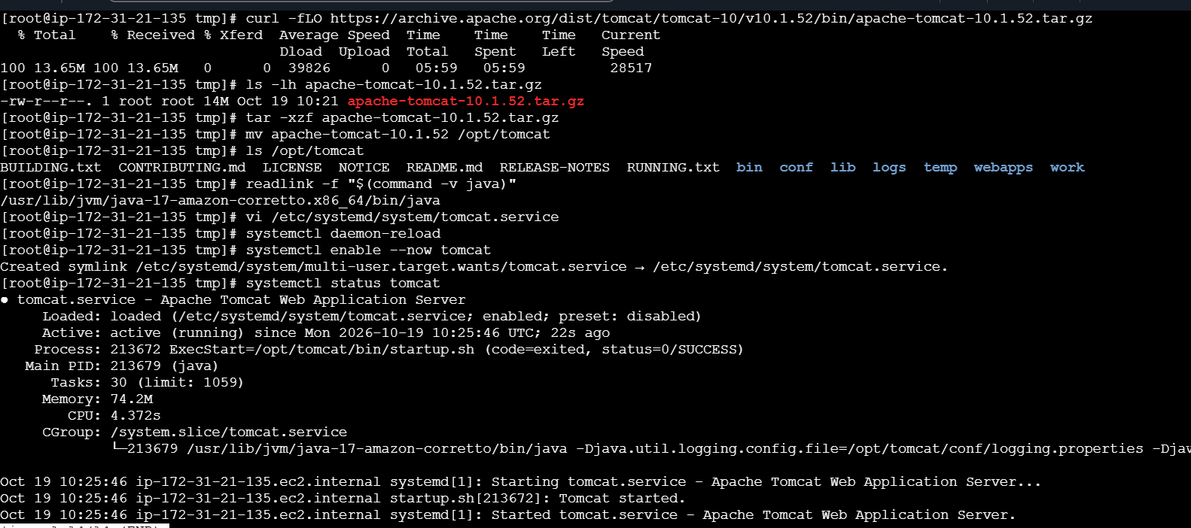

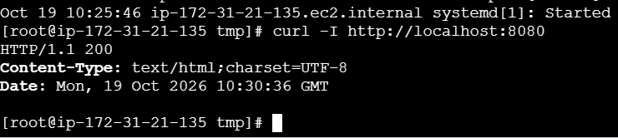

6.Create a bash script to check if the Nginx service is running, if not running then script should start the service.
- Open the EC2 terminal.
- Navigate to /root/bash_tasks.
- Open the script using vi task6.sh.
- Enter the commands to check whether Nginx is running.
- Add commands to start Nginx if it is stopped.
- Save the script and exit Vim.
- Execute using bash task6.sh
Commands I used:
cd /root/bash_tasks
nginx -v
systemctl status nginx
vi task6.sh
bash task6.sh
systemctl is-active nginx
cat /root/bash_tasks/task6.sh

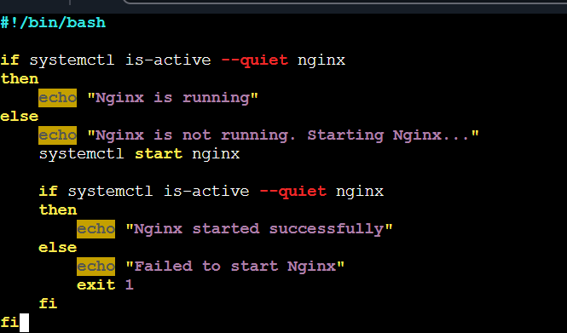

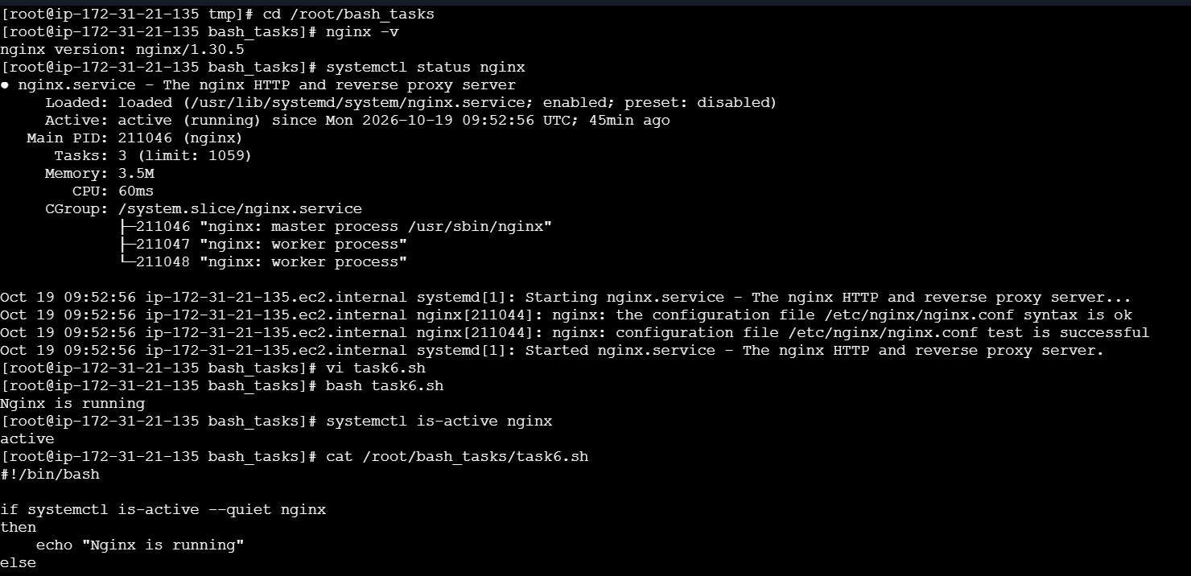
7.Create a bash script for a calculator.
- Open the EC2 terminal.
- Navigate to /root/bash_tasks.
- Open the script using vi task7.sh.
- Enter the calculator commands.
- Save the script and exit Vim.
- Execute using bash task7.sh.
- Enter two numbers when prompted
Commands I used:
cd /root/bash_tasks
vi task7.sh
bash task7.sh

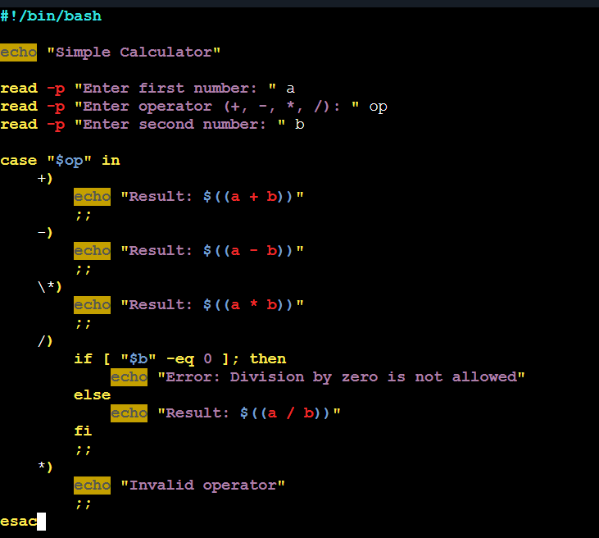

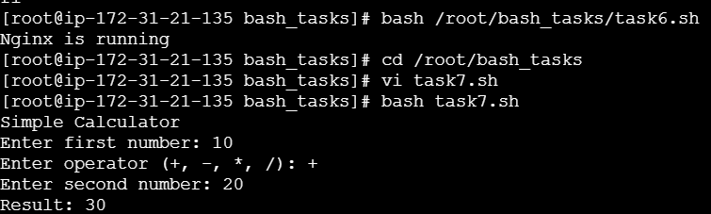

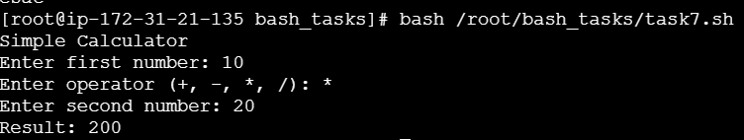
8.Create a bash script to check if a directory exists, if not then create a directory.
- Open the EC2 terminal.
- Navigate to /root/bash_tasks.
- Open the script using vi task8.sh.
- Enter the commands to check whether the directory exists.
- Add commands to create the directory if it is missing.
- Save the script and exit Vim.
- Execute using bash task8.sh.
Commands I used:
cd /root/bash_tasks
vi task8.sh
bash task8.sh
ls -ld /root/mydirectory
cat /root/bash_tasks/task8.sh
bash /root/bash_tasks/task8.sh

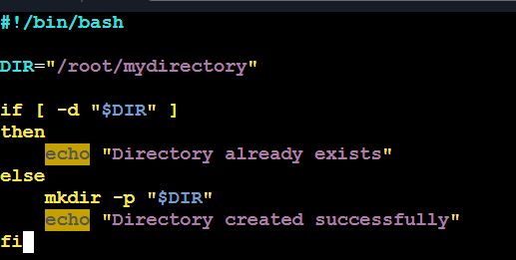

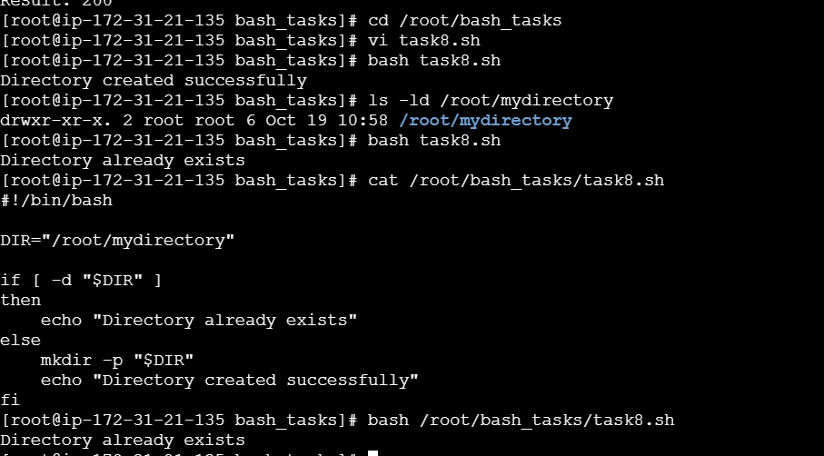

9.Create a bash script to delete the last 3 lines of a file.
- Open the EC2 terminal.
- Navigate to /root/bash_tasks.
- Create a sample text file with ten lines.
- Open the script using vi task9.sh.
- Enter the commands to delete the last three lines.
- Save the script and exit Vim.
- Execute using bash task9.sh.
Commands I used:
cd /root/bash_tasks
cat > sample.txt <<'EOF'
Apple
Banana
Orange
Mango
Grapes
Pineapple
EOF
cat sample.txt
vi task9.sh
bash task9.sh
cat sample.txt
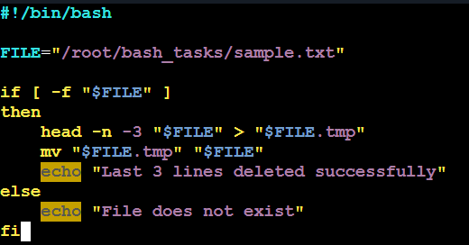

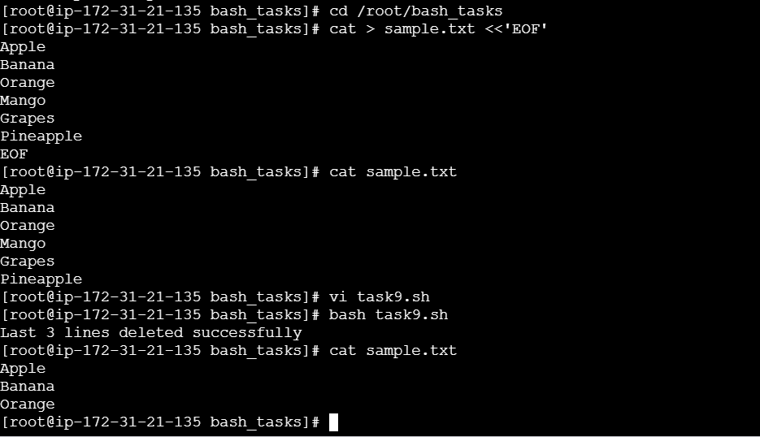

10.Bash script to monitor cpu and if it is more than 80% then send email notification.
- Open the EC2 terminal.
- Navigate to /root/bash_tasks.
- Open the script using vi task10.sh.
- Enter the commands to calculate CPU usage.
- Set the CPU usage threshold to 80%.
- Add conditions to display a warning when usage exceeds the threshold.
- Save the script and exit Vim.
- Execute using bash task10.sh.
Commands I used:
cd /root/bash_tasks
top
top -bn1 | head -5
vi task10.sh
bash task10.sh
cat /root/bash_tasks/task10.sh
bash /root/bash_tasks/task10.sh

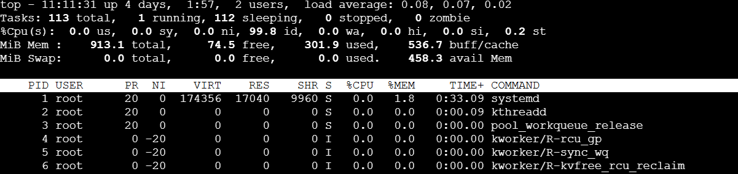

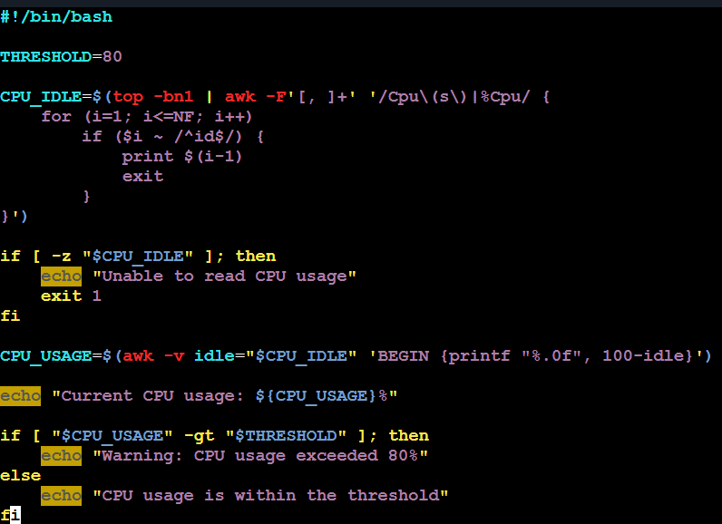
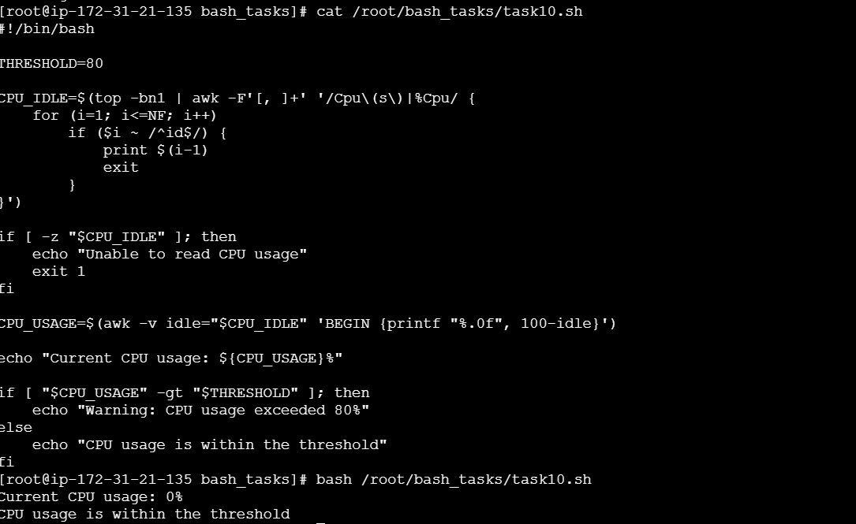

11.Bash script to monitor disk space and if it is more than 80% then send email notification
- Open the EC2 terminal.
- Navigate to /root/bash_tasks.
- Open the script using vi task11.sh.
- Enter the commands to check disk usage.
- Set the threshold to 80%.
- Add conditions to display a warning when disk usage exceeds the threshold.
- Save the script and exit Vim.
- Execute using bash task11.sh.
- Verify using df -h
Commands I used:
cd /root/bash_tasks
df -h
vi task11.sh
bash task11.sh
cat /root/bash_tasks/task11.sh
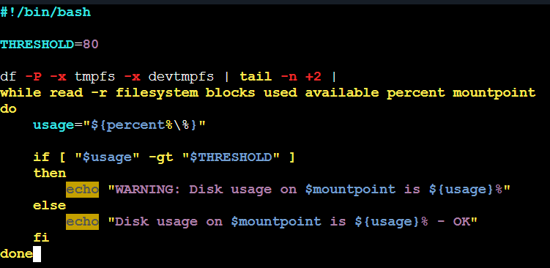

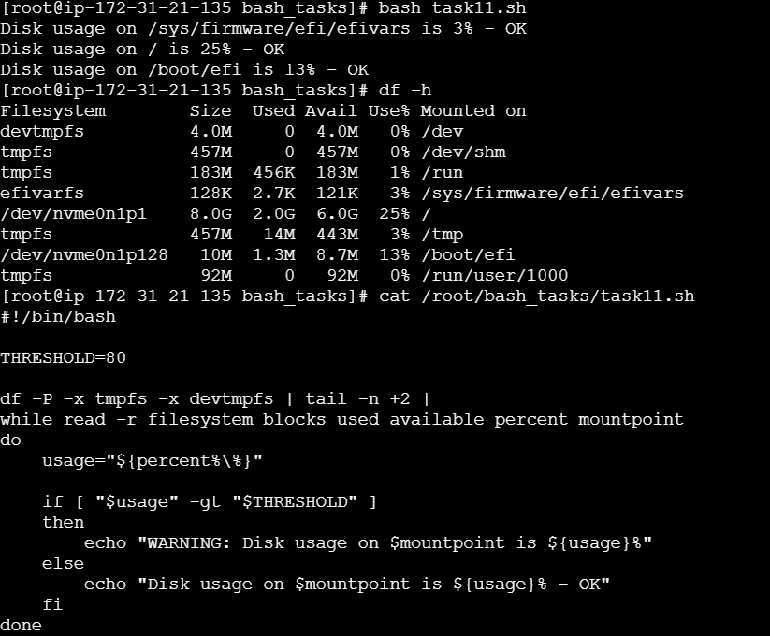

12.Bash script to monitor memory and if it is more than 80% then send email notification
- Open the EC2 terminal.
- Navigate to /root/bash_tasks.
- Open the script using vi task12.sh.
- Enter the commands to calculate memory usage.
- Set the threshold to 80%.
- Add conditions to display a warning when usage exceeds the threshold.
- Save the script and exit Vim.
- Execute using bash task12.sh.
- Verify using free -h

Commands I used:
free -h
cd /root/bash_tasks
vi task12.sh
bash task12.sh
free -h
cat /root/bash_tasks/task12.sh

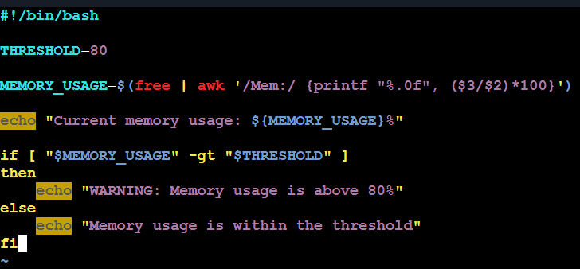
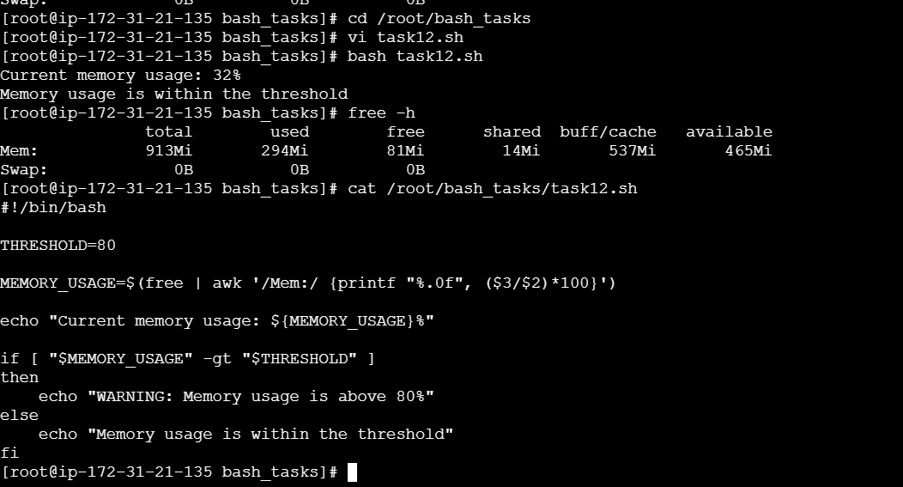

Exercise: Crontab Entries

- April 5th Midnight
- 5th of Every November, January, June if it is a Thursday
- At 05 and 27th minutes of 9, 10, 11 hours every day
- 34 minutes of 9th hour on 15th August
- Every midnight
- Every Weekend (Saturday night 11:59 PM)
- After every reboot
Steps to execute:
- Open your EC2 terminal and switch to root using sudo -i.
- Run mkdir -p /root/bash_tasks.
- Run crontab -e.
- Enter all 7 entries above, without the comment lines if you prefer.
- Save and exit Vim using Esc, then type :wq and press Enter.
- Run crontab -l to verify all entries.
- Check the logs using cat /root/bash_tasks/cron_task1.log and the corresponding log filename for each task after it executes.

